NATIONAL UNIVERSITY OF COMPUTER AND EMERGING SCIENCES
PROGRAM: SOFTWARE ENGINEERING



OPERATING SYSTEMS LAB
ASSIGNMENT-01

SUBMITTED BY:
Name: Ahmed Ali
Roll No: 22P-9318
Section: BS(SE)-5B

INSTRUCTOR NAME: Sir Saad Ahmad
A DEPARTMENT OF COMPUTER SCIENCE

So Before Moving to Actual Work of Assignment We will try to remove some dependencies issues. For that first of all I will update my system by using command sudo apt update.
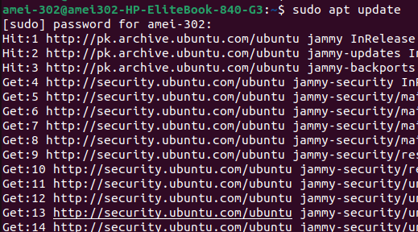
Now for downloading and installing some necessary tools that will help in removing dependencies issues like gcc, ncurses, bison, flex, libssl-dev and libelf-dev we will use the following command: sudo apt install build-essential libncurses-dev bison flex libssl-dev libelf-dev
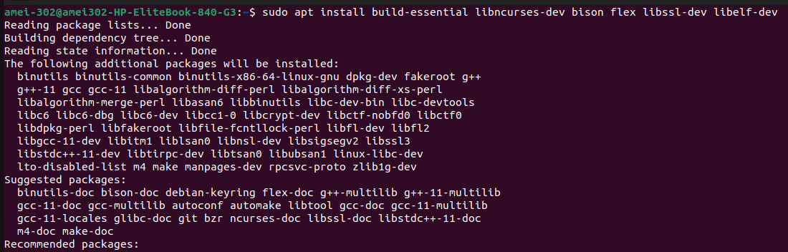

After installing necessary tools and removing dependencies issues we Created the Backup Directory using the command
Now Command for backing up the current kernel in backup directory that we have created:

simply copies your current kernel image (the one you're currently running) to the ~/backup/ directory. This provides a backup of the kernel before making any changes, like compiling or upgrading a new kernel.
Now your kernel has been backed up in a directory.

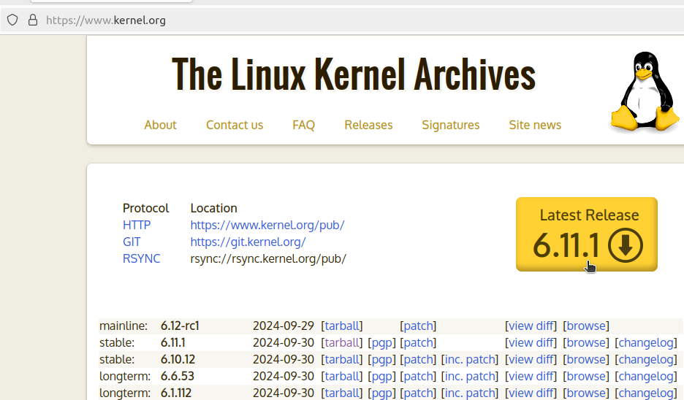
Next, download any version of kernel from https://www.kernel.org, I have downloaded the latest version kernel 6.11.1, I have pointed the cursor on the option as shown in image below click on it and the download will start automatically.

Command used to extract the kernal file is tar -xvf linux-6.11.1.tar.xz
(tar -xvf <name of file with .tar extension>)
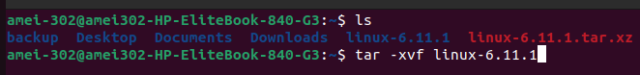

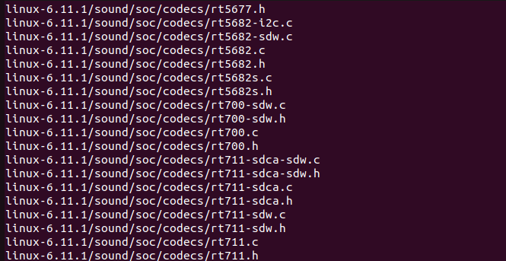
Kernal extraction Process:
Moving into new kernal directory

Now we will configure and customize the kernal:
type the command of make menuconfig a screen will appear in front of you
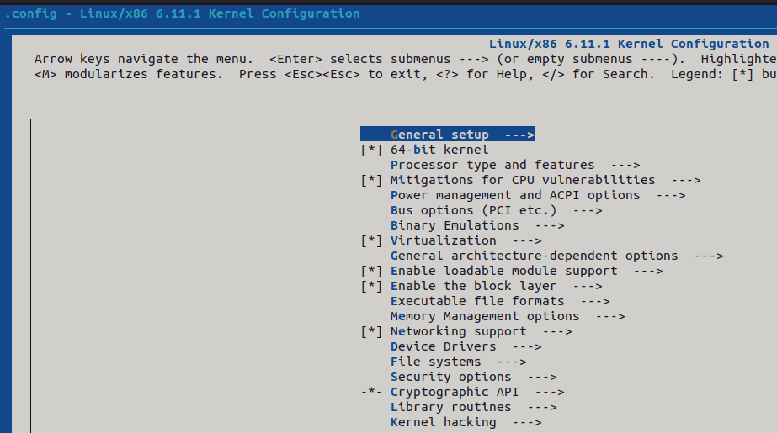

I have disabled the MMC/SD/SDIO card support from device drivers which means the memory card/ micro sd card drivers.
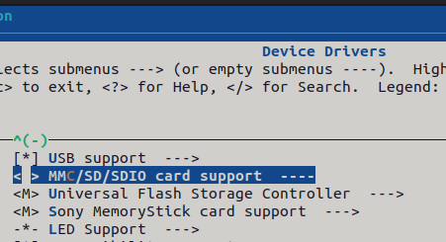

Then I disabled the Memory technology devices MTD which is used for embedded systems and flash memory chips from device drivers

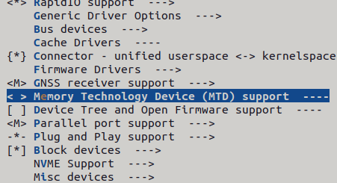

As My pc does not support touch input so I moved to Device Drivers>Input device support>Touchscreens and disabled Touchscreen drivers.
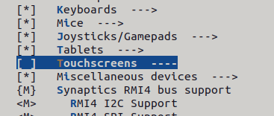

Save it with .config name and press <esc><esc> for doing more customization, It will go back.

Now I go in Networking support>Networking options, and disable older and unused network protocols.
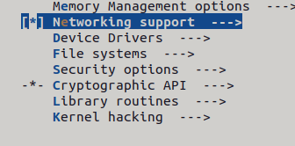
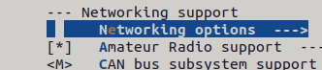

First of all I disabled Appletalk protocol support:
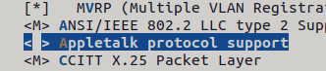

now I press <esc><esc> and come in Networking support option. Here I disabled the bluetooth subsystem support as I do not use bluetooth support in my pc

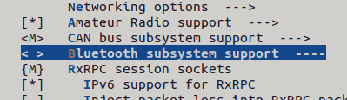

Now I press<esc><esc> and go in device drivers there I disabled the InfiniBand Support which is used for high-performance computing clusters.
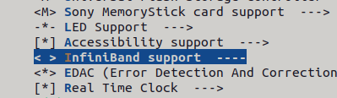

In the Device drivers I moved in IEEE 1394 (FireWire) support and disabled all drivers from there as I do not use any fireWire devices on my system.

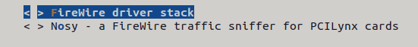
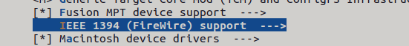

Disabling old/unused sound cards drivers, In the Device driver disable sound card support
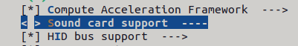

Disabling Virtual Terminal
Device Drivers>Character devices>Virtual Terminal
this is safe to disable if you're using a graphical interface and don't need virtual terminals for troubleshooting)



Drivers to Keep

Input Devices (Keyboard/Mouse):
- Enabling drivers for standard input devices like keyboards and mice.
- Location: Device Drivers>Input device support>Keyboards/Mouse.
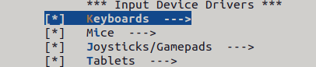

Graphics Card Drivers:
- Enabling and keeping drivers for your GPU
- Location: Device Drivers>Graphics support
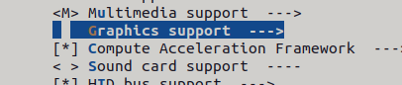

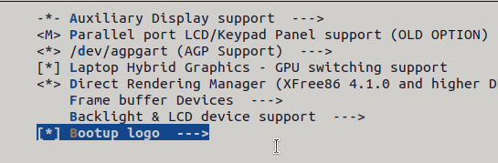
USB Support:
- Keep USB device support for peripherals like external drives, keyboards, and mice.
- Location: Device Drivers>USB support
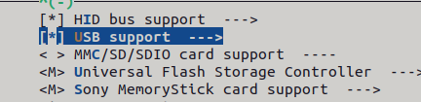

Ethernet/Wi-Fi Drivers:
- Keep drivers for wireless (Wi-Fi) network cards.
- Location: Device Drivers>Network device support>Wireless LAN
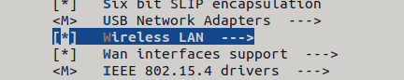

File System Drivers:
- Keep drivers for the file systems you use (e.g., ext4).
- Location: File systems>



I enabled the Ext4 debugging support for making kernal more efficient.
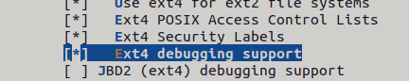

After this I Select the save command and then Exit, and again I come back on terminal.
Compiling Kernel:
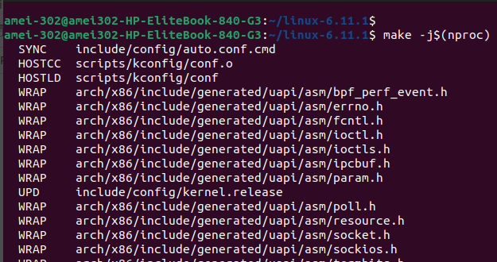
Instead of manually specifying the number of cores, $(nproc) automatically adjusts to the number of cores on your machine.

While the compilation of kernal I have faced one issue of permission that was occurring due to the file owner name was root so I used sudo chown command and rename the file owner name according to my system name.
Now all file names are according to my system name.
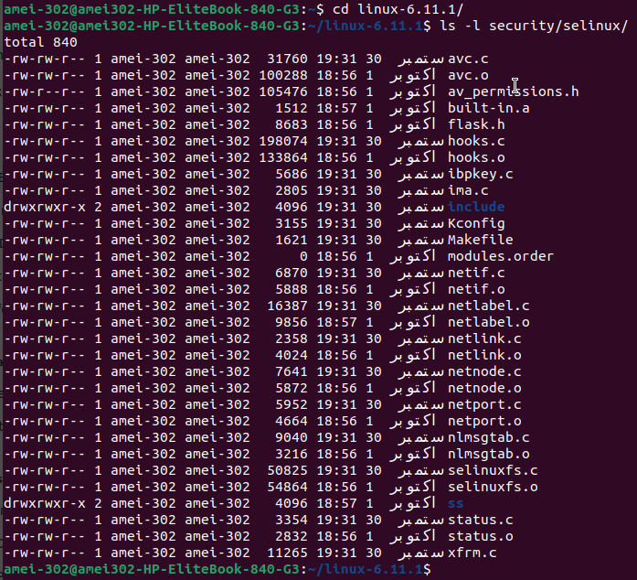
Again I compiled the kernel using command make -j$(nproc) and it has successfully compiled the kernel according to customization.

Installing the Kernel and Modules
For installing the modules we will use the command sudo make modules_install, This command will install all modules of kernal that were compiled during the kernel build process.
These modules are loadable kernel modules that can be loaded or unloaded dynamically at runtime, this will copy all the compiled modules to the appropriate location on your system lib/modules/kernel-6.11.1.
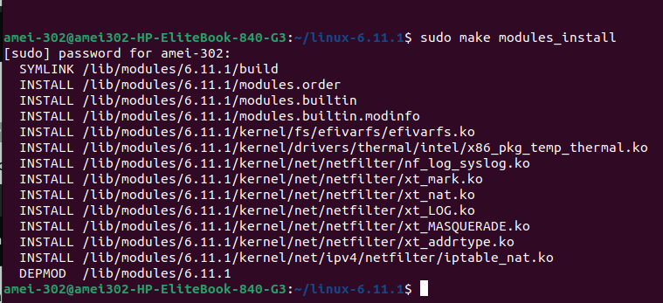

Next, we will install the newly compiled kernel image and related files: sudo make install this will copy the newly compiled kernel image to /boot preparing the system to boot with the newly compiled kernel.

(SEE BELOW FOR ATTACHED SCREENSHOT ON NEXT PAGE)
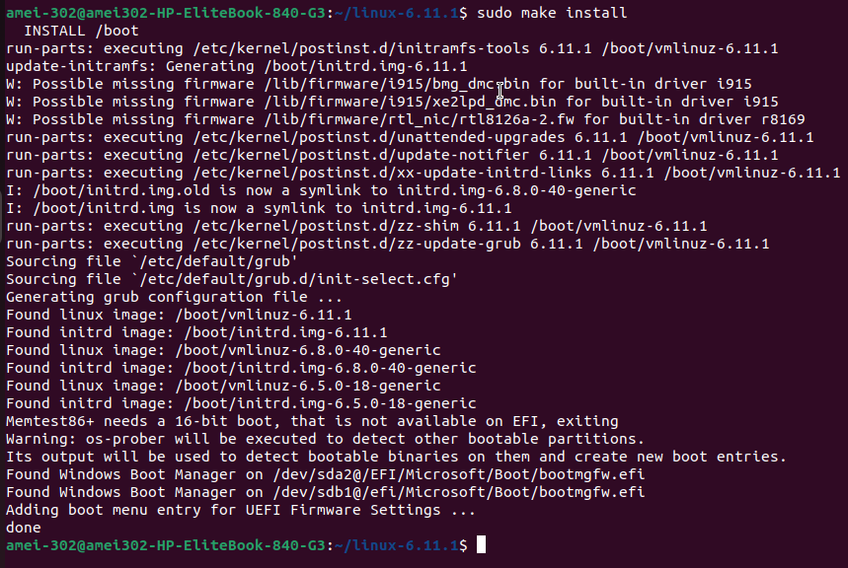
Updating the Bootloader:
GRUB (Grand Unified Bootloader) is a bootloader used in Linux systems to load the operating system kernel, it allows users to select from multiple operating systems or kernel versions during system startup. GRUB is highly flexible, supporting different file systems and Operating Systems, and provides a user-friendly menu for booting.
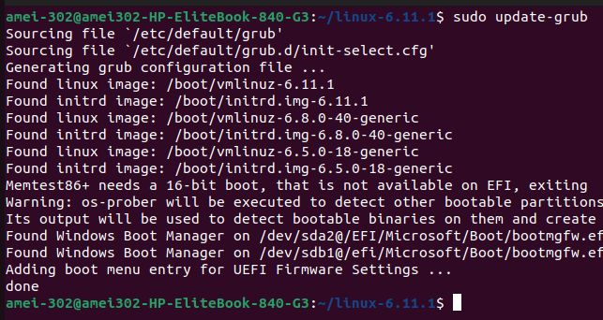

My Current Version Of Kernel
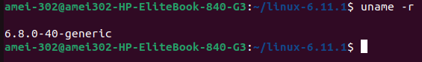

Reboot and Select the New Kernel:
When the system boots up, select your newly installed kernel from the GRUB menu.

While rebooting the GRUB Bootloader interface will appear in front of you;
1. Select Advance Option for UBUNTU
- There List of Kernels will appear, Select the newly compiled kernel by remembering its version like in my case it was linux-6.11.1, So I know which kernel to Select.

I have captured some pictures, They are attached Below:
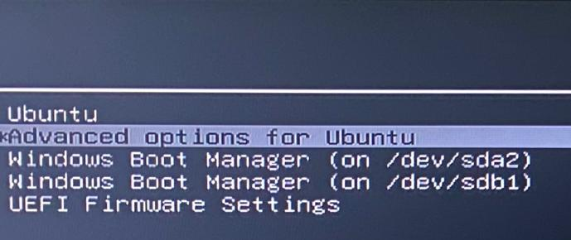

while rebooting when the GRUB Bootloader interface appears select Advanced options for UBUNTU and hit enter key.
Now a list of kernels that are compiled at your system will appear here. I selected the Linux 6.11.1 (the latest kernel) as I have downloaded it, made customization in the kernal according to myself and compiled it and press enter key.
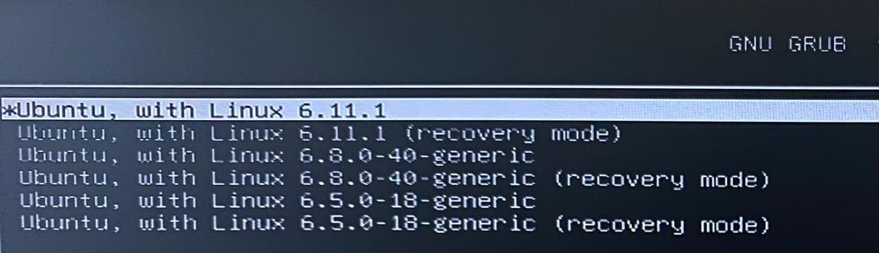

After You press Enter Key, it will take a while to process the kernel.
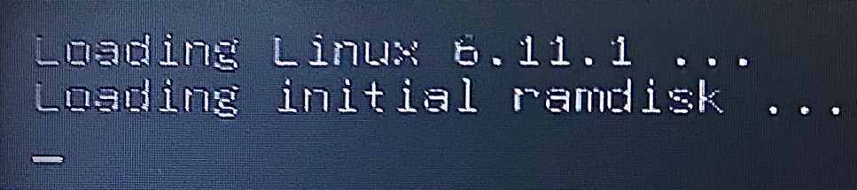

After execution of kernel, The first thing I noticed on my screen is:
1) the sound option is showing but I cannot hear the voice of any song.
2) No internet
3) unable to access the drives other than Ubuntu
4) symbols of back and forward are changed
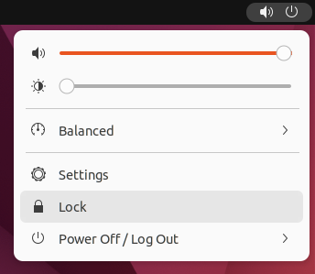
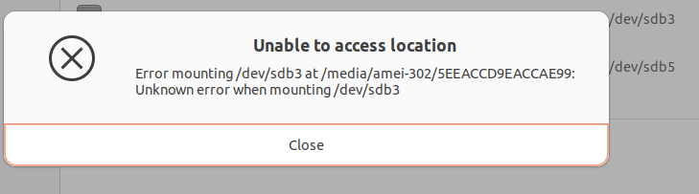

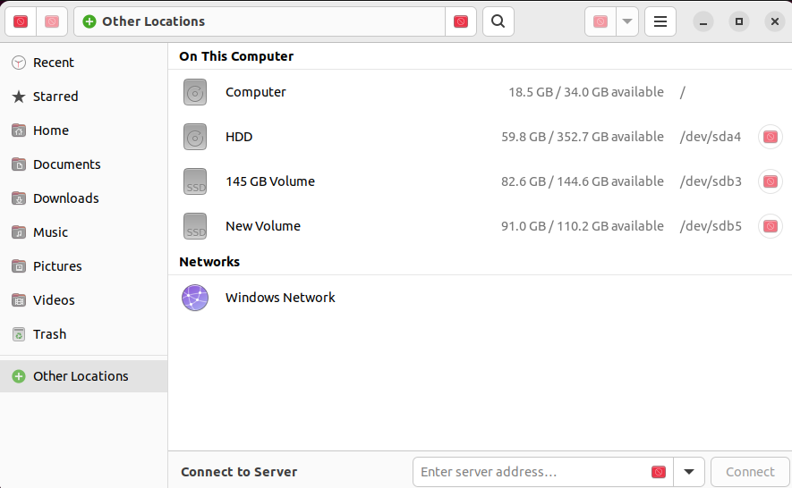

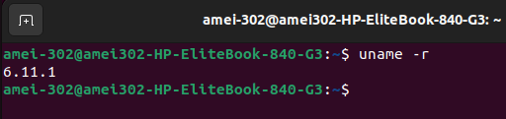
New Version Of Kernel:

